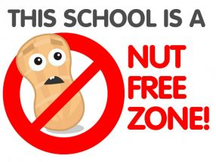

As a school we accommodate children with all types of allergies, so at times we must omit certain food groups into the school. We are now a NUT FREE ZONE! Please can we ask that you do not send any items in your child’s lunchbox that contain nuts. Thank you.

