Cam Woodfield Infant School Newsletter 02.10.20

Beginning of the school day
Please can we remind parents to stick to the start times for their child’s class. We have a number of children arriving as much as 10 minutes late who are missing the start of the school day. This is also resulting in class bubbles being in the playground at the same time, which we are working hard to avoid. The classroom doors will be locked 5 minutes after the class start time. After this time, you will need to walk round to the front door for your child to come in.
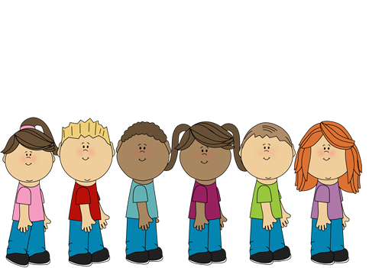
Please can we also remind parents to ensure that their children line up ready to enter the school. This is so that other parents and children can walk across the playground safely whilst ensuring social distancing.
Class Start time Door locked at
Squirrel 8.40am 8.45am
Owl 8.50am 8.55am
Rabbit 9.00am 9.05am
Badger 9.00am 9.05am
Hedgehog 9.10am 9.15am
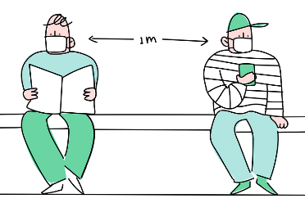
Social Distancing
A huge thank you to everyone who is working hard to ensure that they are social distancing from others to ensure that safety of the children, staff and parents. Please ensure that you are standing 1 metre from others if you are wearing a mask. If you are exempt from wearing a mask you should be standing 2 metres from others.
Clubs
We will be restarting Sports / PE clubs after school from next term. Due to Covid-19 restrictions we cannot mix the class bubbles so the clubs will be restricted to specific classes. There will be places for 15 children in each club as we cannot safely accommodate any more in the hall at this time. There will be 2 opportunities for clubs, for each class during the academic year. If the club is oversubscribed we will allocate places on a first come – first served basis.
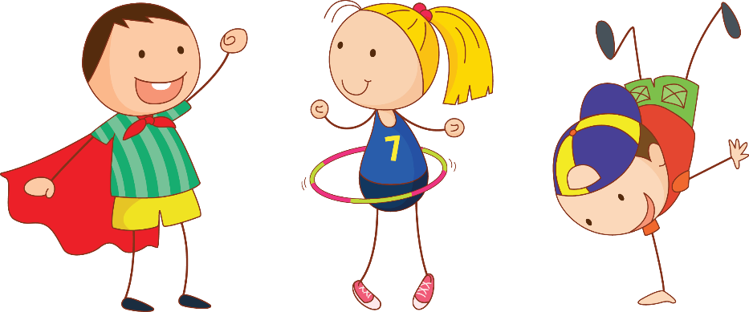
Term Weds Fri
2 Hedgehogs Squirrels
3 Owls Hedgehogs
4 Squirrels Owls
5 Badgers Rabbits
6 Rabbits Badgers
The teachers will be asking the children what sort of sports they would like the club to be. The form will come out via Parent Mail next week for HEDGEHOGS and SQUIRRELS so please look out for it! Make sure that you have downloaded the App so that you get a notification!

Reading
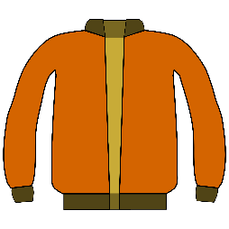
Reading books are being changed on Mondays and Thursdays. If your child’s books need to be changed please ensure that you have put them in their bookbag. Any comments that you would like to make, for the teacher to see should be posted on Tapestry.

Coats
Despite the recent weather we still have a number of children coming in without coats. It is essential that your child now comes to school with a cost EVERY DAY.
Covid-19 Home School Agreement
There are still a few agreements that we have not received. Please return these as soon as possible.
SEN and My Plans (REMINDER)
The teachers are currently reviewing the My Plans and drafting new targets. If this applies to you, they will be in touch with you soon to discuss these and to seek your suggestions and support.
Contact
Telephone: 01453 543535
Email Janet Hollister (Admin Officer): admin@woodfield.gloucs.sch.uk
Email Helen Harper (Head Teacher): head@woodfield.gloucs.sch.uk

