Cam Woodfield Infant School Newsletter 22.10.20

We have come to the end of our first term back this year. We have been very impressed with the way that the children have settled back in to school despite the new way of doing things. They have taken the changes on board well and got back in to work. We have been doing our weekly celebration assembly by using Microsoft Teams and the children have really enjoyed seeing their friends and siblings receive certificates and wishing them a happy birthday.
A big thank you to the parents for ensuring that they are keeping their distance from others and for wearing masks. This is extremely important, to ensure that we are protecting each other, as there are a number of vulnerable people within our school community. We are aware that there are a few parents / carers who are exempt from wearing a mask and those parents have approached the school to mention this.

Could we remind you that the children should not be going on the equipment in the playground before and after school. Please could you also ensure that your child does not pull down the tape that has been put up.
Flu Immunisation
The year 1 and 2 children that were in school on Tuesday 20th October had their flu immunisation. The school nursing team will be coming back in to school to do the immunisation for the Reception children and any children who were not in school on that day. As soon as we have been given a new date we will let you know.
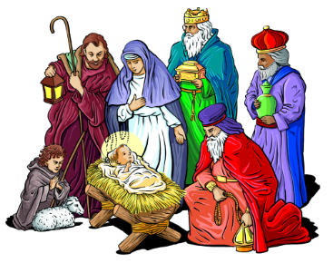
The Wonder Wander Nativity Trail
The local churches are running a nativity drawing competition. Your child can draw one of the characters from the nativity and colour in on the competition form you will receive in your book bag. The winning entries will be ‘blown up’ so that they are life size ready for the nativity trail that you will be able to follow from 27th November until Christmas Day. Please drop your entry form into Froffy Coffee, Cam Post Office, Dursley Post Office, Kingshill House, Uley Post Office or Coaley Village Stores by 12.30pm and 9th November.
Toys in school
Please can we remind you that children should not be bringing any toys in to school. This includes lego cards, fluffy toys and key rings. The only things in book bags should be reading books, letters that are sent home / returned and word key rings.
Parents Evenings
We will be holding Parents Evenings by video call on Wednesday 11th and Thursday 12th November. We have introduced an online booking system which allows you to choose your own appointment with your child / children’s class teacher/s. The booking system opens on Friday 23rd October at 4pm and can be found out https://camwoodfieldinfant.schoolcloud.co.uk. Please find attached a short guide showing how to book appointments with this email.
Water Bottles
Please could you ensure that your child’s name is on their water bottle in school. There are a number of children with the same bottles and it is not easy to tell which belongs to who! As a healthy school please could you ensure that your child has water in their bottles rather than squash.
Tables in classrooms
Next term we will be trialling moving the children’s tables back into groups again. This is so that the children have more opportunities to talk and work with each other. The children will remain in their bubbles at all times with the windows open for ventilation. The children are good at sneezing and coughing into their elbows, putting tissues in lidded bins and washing and sanitising their hands.
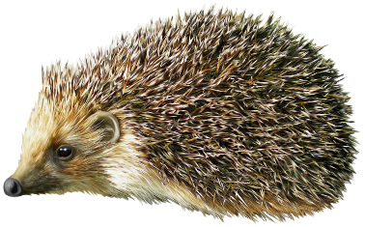
Hedgehog Class
We have had a fantastic first term in Hedgehog Class. The children have enjoyed our 'Who Is a Superhero?' topic and have learned about real life superheroes such as Edward Jenner and Florence Nightingale with such enthusiasm. We have produced some great Pop Art pictures in the style of Andy Warhol. These were so good that we have displayed them in the corridor! The children were very excited to share their superhero dances with you, so I have uploaded them to Tapestry for you to enjoy. I have been particularly impressed with the manners of the children in our class; I have seen lots of children helping each other out and saying 'please' and 'thank you'. The children have all settled back into school incredibly well after such a long time away and we are all very proud of them. Our topic after half term will be 'Where In The World Am I?'
Miss Collings and the team
Rabbit Class
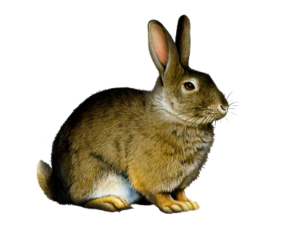
Well done on a great first term in school Rabbit class. You all come into school with such smiling faces each day and you have settled in so well. Mrs McHale and I are so proud of you. We have enjoyed learning all about Marvellous Me and you are all very special and unique as we learnt on Monday. After half term our topic is called Sparkle and Shine where we will be learning about lots of different special occasions leading up to Christmas. During the break I would love you to practice putting the sleeves of your coat in the right way and then be able to do up your coat independently. Have a nice break from school and I look forward to seeing you on Monday 2nd November.
Mrs Cassé and Mrs McHale
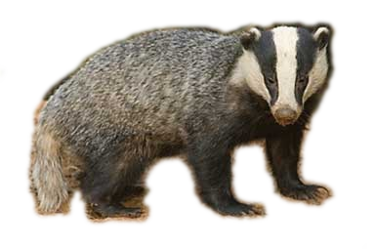
Badger Class
I’d like to say a great big well done to all Badgers. I am so proud of how well you have all settled into school with such happy, smiley faces. We have been very busy learning lots of new things and I am amazed at how quickly you have remembered the sounds and their actions. Next term our topic will be Sparkle and Shine where we will be learning about lots of special occasions we celebrate each year. I would really like it if you could all practice putting your coat on and zipping it up all by yourself as the weather will probably be a lot colder next month. Have a lovely half term.
Mrs. Lightfoot and Mrs Thumwood
Squirrel Class
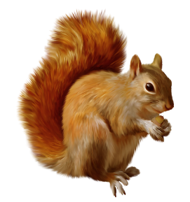
We have loved having the children back this term and they have all settled in really well. We have had lots of fun this term doing our Superhero Topic. The children have been SUPER stars!!
We have been really busy… We have made masks, danced like superheroes, used our superhero senses, talked about real life superheroes, learnt about Florence Nightingale and Edward Jenner, painted like Andy Warhol and did some amazing poetry. Phew!!! We are really proud of all the children and we are looking forward to more fun next term. Have a lovely restful half term.
Mrs Powell and Team

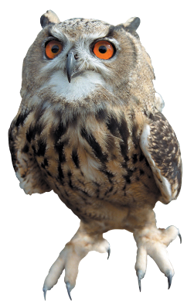
Owl Class
We have had a fantastic first term in Owl Class and the children have settled back into school really well! They have loved the ‘superhero’ topic and have produced some brilliant art work which we have put on display around the school. They also designed and made a fantastic superhero mask! The children have enjoyed learning about real-life superheroes, including Florence Nightingale and Edward Jenner. They have also produced some brilliant superhero poems. The children have worked really hard over the term to put together a fantastic superhero dance – this is on Tapestry for you to watch!
Next term our topic is called ‘Where in the World am I?’ During this topic the children will have the opportunity to learn about their local area, as well as other parts of the world.
Thank you for your continued support. We have loved having the children back in school again and are so proud of how well they have adapted to the new routines.
Have a lovely half term.
Mrs Cox and Mrs Dunning

Contact
Telephone: 01453 543535
Email Janet Hollister (Admin Officer): admin@woodfield.gloucs.sch.uk
Email Helen Harper (Head Teacher): head@woodfield.gloucs.sch.uk

