CAM WOODFIELD INFANT SCHOOL
Friday 20th November 2020

Christmas is around the corner!
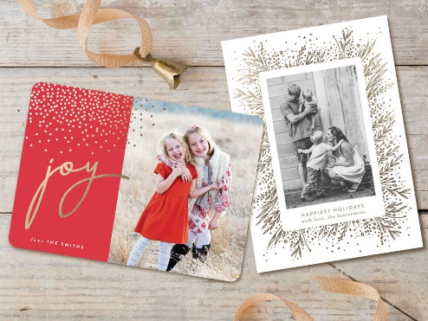
Christmas Cards
Due to the ongoing Covid-19 situation we have been advised by the Local Authority not to have Christmas cards coming in to school and being passed around. Instead of Christmas cards please could we ask you to put a post on Tapestry. It may be a Christmas picture, card or even a short video message that the children would like to send to their friends. The teachers will share these in class with all of the children.

Pantomime
Despite Covid-19 the children are still going to experience a pantomime this year. The company that we usually use, West Midland Children’s Theatre, is making the pantomime available online. This year the panto is ‘Cinderella’ and the children will be watching it online in their classes during December. The panto has even been adapted so that the children can join in! There will be comedy, laughs, singing, dancing and even some custard pies (on screen).
Christmas Lunch
The kitchen will be cooking the children a Christmas lunch on Thursday 17th December and you should already have received a letter asking if your child would like one. Please make sure that this is returned as soon as possible, if you have not already done so.

Christmas Presents
There are some parents who would like to know if the children can still give a present to the staff at Christmas. Whilst we are not able to have Christmas cards in school, due to the amount they are passed around, you are able to bring a present in. The staff will not be able to open these with the children but will have to quarantine the presents for 72 hours.

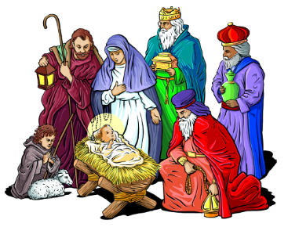
Nativity
Unfortunately, we are not able to do Christmas Nativities in the usual way. However, each class will be putting something Christmassy together which they will be putting on Tapestry towards the end of term.

Christmas Parties
The teachers will be arranging a Christmas party for their class bubble during the last week of term. Children will be able to wear their party clothes on the day of their party. More information will be sent out in December.

Christmas Jumper Day
This is on Friday 11th December and children are welcome to wear their Christmas jumper to school if they have one. Donations in aid of Save the Children can be made via Just Giving. More details of the Just Giving site will follow nearer the time.

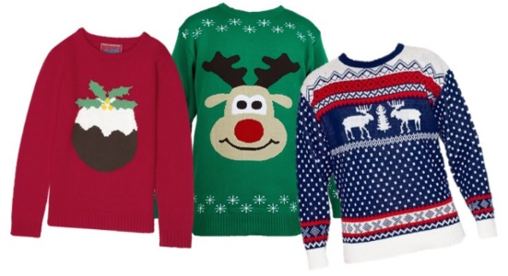
This Photo by Unknown Author is licensed under CC BY-NC-ND
End of Term Finishing Times
The last day of term is Friday 18th December. School finishes an hour earlier, so the finishing times for each class are:
Squirrels Class – 1.55pm
Owl Class – 2.05pm
Rabbit Class – 2.15pm
Badger Class – 2.15pm
Hedgehog Class – 2.25pm

