Dear Parents /Guardians
It has been brought to our attention that there are currently some issues regarding parking in the Strawberry Field’s area.
I have visited the residents and have spoken with them regarding this, the main issue we have is the parking of vehicles in the tarmacked areas outside of the properties. The parking area in Strawberry fields is for residents only so there for private. If you could please refrain from parking in this area it would be much appreciated by all the residents.
It was also mentioned that when vehicles are parked along the walled area and opposite they are causing an obstruction for people driving in and out as it is too narrow when vehicles are parked either side. Please be aware when parking that you are not causing an obstruction and you are being sensitive to the residents in the area.
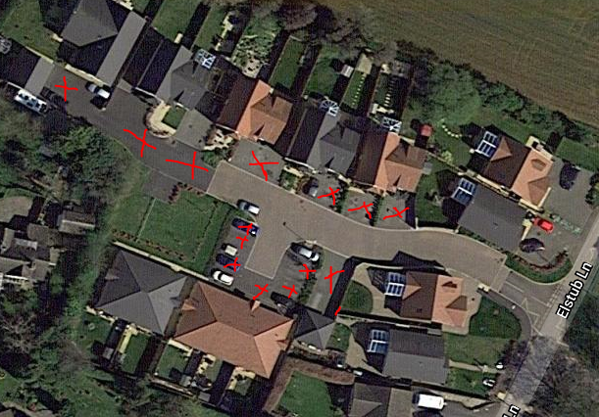
Liz Ward 9081
Police Community Support Officer
Stroud Local Policing Team
Dursley Police Station
Gloucestershire Constabulary
Dursley Police Station | Sandpits | Dursley | GL11 5QE
Personal – 01452 753672 | www.gloucestershire.police.uk | Twitter page | Facebook page

