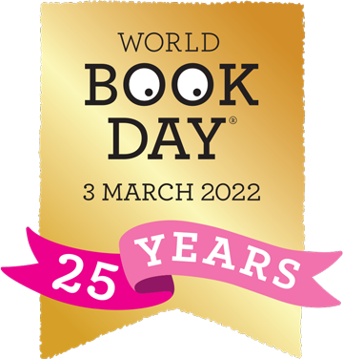

Dear Parents and Carers

To celebrate World Book Day on Thursday 3rd March we would like to invite the children to dress up as a book character of their choice. Please don’t feel that you have to go out and buy a costume, there are so many great DIY ideas that you can re-create! It would also be lovely if the children could bring their favourite book into school to show to the rest of their class.
Throughout the day the children will take part in lots of fun book related activities in their year groups.
If you have any questions then please speak to your child’s class teacher.

Thank you for your support.
Annabelle Cox

