
Dress in red, white and/or blue on Friday 27th May

Dear Parents / Carers,
We are all excited in school as we prepare for our Platinum Jubilee celebrations which we are going to hold on the last day of term (Friday 27th May 2022).
In the morning, all of the children will be coming together to share songs and watch a short film about the Queen so that the children understand why we are celebrating. The children have started to learn the National Anthem and are doing really well! Maybe you could help them to practice it at home.
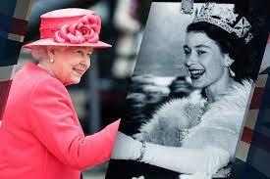
We are going to have a ‘Street Party Lunch’ and we have invited the Nest to share in our lunchtime celebrations. As long as the weather is good we will be taking the tables out in to the playground and having a street party of our own. The kitchen is preparing sandwiches, spring rolls, sausage rolls, goujons, coleslaw, houmous, garlic dip, fruit platter and cupcakes. The school will buy some crisps to add to this, and Year 1 are making cakes for the whole school as well! This is in place of a cooked meal. If your child would prefer to have a packed lunch, they are welcome to bring one in.
We will have music playing, so hopefully there will be some singing and dancing. The Year 1 and 2 children are doing some screen printing to make some flags that they can wave on the day and the Reception children will be making fabric flags. They will be able to bring them home afterwards to use in your own celebrations. We would love the children to come dressed in red, white and/or blue. They will be making crowns to complete their outfits!
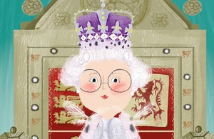
Cam Parish Council are going to give each of the children a commemorative bookmark. The school is also expecting to receive a commemorative book for each of the children from the DfE (Department for Education). It is a story of a young girl, Isabella, visiting her Great Granny Joyce who tells her about the Queen and this year’s Jubilee. It also has some quotes from the Queen as well as facts and figures.
At the end of the day we would love to sing the National Anthem to the parents / carers and wave our flags (weather permitting). We invite you to join the whole school in the playground at 3.00pm.
Helen Harper
Head Teacher

