Friday 9th September 2022
Cam Woodfield Infant School
BEGINNING AND END OF THE DAY

We hope that you have all had a great summer and had a chance to do some fun things! The Year 1 and 2 children have come in really well over the last few days with big smiles on their faces – what a great start!
You will have noticed that we have a new fence outside Squirrel and Fox Classes. This has been erected so that we can create a really nice outdoor space for those two classes – watch this space!!
Welcome to all of the new reception children and families. It has been lovely to see you all coming in to see the teachers and we are all looking forward to welcoming you to our school community.

WELCOME BACK

08.45 – Children can come in to the playground supervised by a parent / carer. Please do not turn up any earlier!
08.50 – Doors open for the children to come in
09.00 – Doors close and teachers do the register
If you are later than 09.00 please Do NOT knock on the classroom door. You will need to go round to the school office.

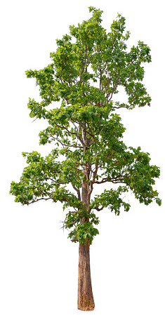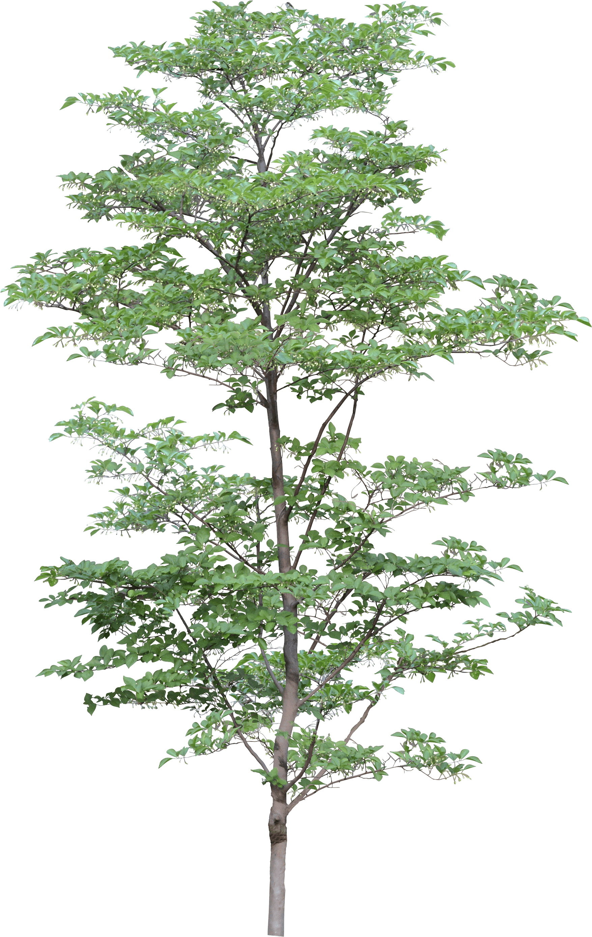

We have been fortunate enough to secure some Forest School sessions for each of the classes through the school year at Redwood (near Slimbridge). Each class will have 6 sessions. Please check the ‘dates’ to see when your child’s class will be going. We will be asking for parents to come along and help us so that we have enough adults.
FOREST SCHOOL AT REDWOOD

Children should NOT be using the Infant Adventure Playground or Junior Trim Trail either before or after school please.
ADVENTURE PLAYGROUND

Please could we ask parents to be mindful that the teachers need to be in their classrooms at 09.00 with the children, doing the main register and dinner register.
If you have some information to quickly pass on then you could do this either before or after school.
If, however, you need to talk at length please do this at the end of the school day. It is important that the teachers are with the children as they start the day.
Thank you.
WHAT DO I DO IF I NEED TO SPEAK TO THE TEACHER?

The main way that we will be communicating with you will be by Iris Parent Mail.
If you are new to the school you will receive an activation link by email early next week. If you have not received the link please pop into the office and Mrs Hollister will sort it out for you!

IRIS PARENT MAIL

WHAT WILL MY CHILD BE DOING THIS TERM?

Your child’s class teacher will be sending home a leaflet next week about:
- the class project
- end of year expectations (academic)
- PE days
- when they will get their reading books
- Tapestry
The teachers will be holding an information evening when they will talk through the curriculum and many other bits and pieces about their class. For Years 1 and 2 this is on Weds 21st September and for Reception it is on Thursday 22nd September. Both will start at 18.00. We would like to encourage you all to come along.
There is also an opportunity this term to go in to your child’s class during the school day to have a look at what they have been doing and see what their class is like. Please have a look at the dates to see when your class will be doing this.
Please could we ask that you name absolutely all of your child’s possessions and clothes. This includes socks, shoes, hats etc… It can be very difficult to reunite possessions (particularly jumpers) when they are not named!

UNIFORM

BOTTLES

Your child will need a named water bottle in school. As we are a healthy school we ask that you provide your child with water unless they have a medical need. If this is the case please speak to your child’s class teacher.

PE Kit

Please could you ensure that your child has their PE kit (named of course!) in school.

PLEASE DON’T FORGET TO SEND YOUR CHILD IN WITH A COAT

SQUIRREL CLASS FOREST SCHOOL AT REDWOOD
A big thank you to the parents who have volunteered to help with the Redwood trips.
In total we need 7 adults. Unfortunately, we still do not have enough adults to cover all of the sessions at the moment so please could I ask you to consider whether you could do any of the sessions. We will only be able to take the children with enough adult support.
It promises to be really great fun that I know the children will love!

SCHOOL RULES
We have recently changed the system we are using in school and now have 3 main school rules. As there are only 3 it makes it much easier for the children to remember. Are you……?
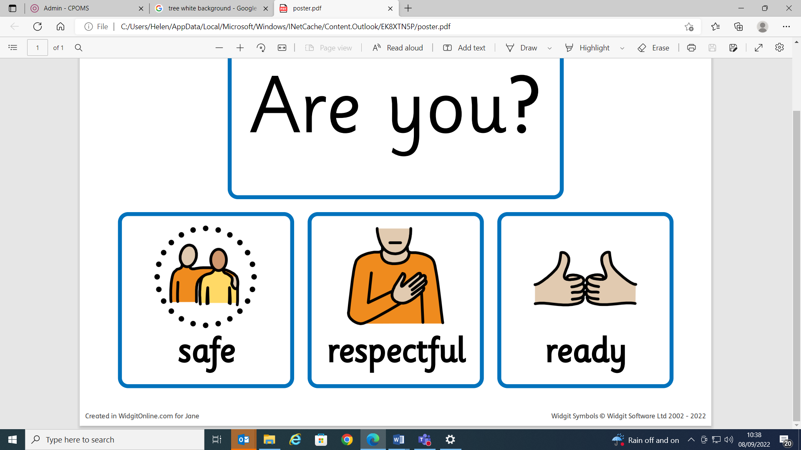

2022 – 2023 DATES
Friday 9th September Reception children starting part time
Teachers
Wednesday 14th September 09.00 Autumn born Reception starting full time
Monday 19th September 09.00 Spring born Reception starting full time
Wednesday 21st September 12.30 –15.00 Squirrel Class Forest School at Redwood
Wednesday 21st September 18.00 – 19.00 Year 1 and 2 Parents Information Evening
Thursday 22nd September 18.00 – 19.00 Reception Parents Information Evening
Monday 26th September 09.00 Summer born Reception starting full time
Tuesday 27th September 14.30 – 15.00 Owl Class parents invited in to the class to see
the children’s work and informally see the teacher / teaching assistant
Wednesday 28th September 12.30 – 15.00 Squirrel Class Forest School at Redwood
Thursday 29th September 14.30 – 15.00 Fox Class parents invited in to the class to see
the children’s work and informally see the teacher / teaching assistant
Friday 30th September 14.30 – 15.00 Squirrel Class parents invited in to the class to
see the children’s work and informally see the teacher / teaching assistant
Wednesday 5th October 12.30 – 15.00 Squirrel Class Forest School at Redwood
Wednesday 5th October 14.30 – 15.00 Badger Class parents invited in to the class to
see the children’s work and informally see the teacher / teaching assistant
Friday 7th October 14.30 – 15.00 Rabbit Class parents invited in to the class to see
the children’s work and informally see the teacher / teaching assistant
Wednesday 12th October 14.30 – 15.00 Squirrel Class Forest School at Redwood
Tuesday 18th October all day Year 1 and 2 trip to Slimbridge
Wednesday 19th October 09.15 Year 1 and 2 Harvest assembly (parents invited)
Wednesday 19th October 12.30 – 15.00 Squirrel Class Forest School at Redwood
Wednesday 19th October 14.30 Reception Harvest assembly (parents invited)
Friday 21st October 15.15 End of Term 1
Monday 31st October 09.00 Start of Term 2
Tuesday 1st November all day Flu immunisations (information to follow)
Wednesday 2nd November 12.30 – 15.00 Squirrel Class Forest School at Redwood
Friday 4th November morning Individual and sibling photographs
Wednesday 9th November 12.30 – 15.00 Fox Class Forest School at Redwood
Thursday 10th November 13.30 – 14.30 Pre-school fun session (for Sept 2023 intake)
Wednesday 16th November 12.30 – 15.00 Fox Class Forest School at Redwood
Friday 18th November all day Children in Need (info to follow)
Wednesday 23rd November 12.30 – 15.00 Fox Class Forest School at Redwood
Wednesday 30th November 12.30 – 15.00 Fox Class Forest School at Redwood
Monday 5th December 13.30 – 14.30 Pre-school fun session (for Sept 2023 intake)
Wednesday 7th December 12.30 – 15.00 Fox Class Forest School at Redwood

2022 – 2023 DATES CONTINUED
Friday 9th December all day Christmas Jumper Day (info to follow)
Monday 12th December 13.30 Reception Nativity (parents invited)
Tuesday 13th December 13.30 Year 1 and 2 Nativity (parents invited)
Wednesday 14th December 09.30 Year 1 and 2 Nativity (parents invited)
Wednesday 14th December 12.30 – 15.00 Fox Class Forest School at Redwood
Thursday 15th December all day Class Christmas Parties
Thursday 15th December 12.00 – 13.00 Children’s Christmas Lunch
Friday 16th December morning Pantomime in school for the children (Sleeping
Beauty)
Friday 16th December 14.00 End of Term 2
w/c 3rd January Autumn term reports to parents
Tuesday 3rd January all day INSET – STAFF ONLY
Wednesday 4th January 09.00 Start of Term 3
Monday 9th January 15.30 – 18.30 Parents Evening
Wednesday 11th January 15.30 – 18.30 Parents Evening
Tuesday 17th January all day Life Bus in for the children
Wednesday 25th January 09.30 – 10.30 Pre-school fun session (for Sept 2023 intake)
Wednesday 8th February 18.00 – 19.00 Year 1 and 2 Parents Information Evening
Wednesday 15th February 12.30 – 15.00 Owl Class Forest School at Redwood
Wednesday 15th February 18.00 – 19.00 Reception Parents Information Evening
Friday 17th February 15.15 End of Term 3
Monday 27th February 09.00 Start of Term 4
Tuesday 28th February 13.30 – 14.30 Pre-school fun session (for Sept 2023 intake)
Wednesday 1st March 12.30 – 15.00 Owl Class Forest School at Redwood
Tuesday 7th March 09.15 – 10.00 Fox Class parents invited in to the class to see
the children’s work and informally see the teacher / teaching assistant
Wednesday 8th March 09.15 – 10.00 Owl Class parents invited in to the class to see
the children’s work and informally see the teacher / teaching assistant
Wednesday 8th March 12.30 – 15.00 Owl Class Forest School at Redwood
Thursday 9th March 09.15 – 10.00 Squirrel Class parents invited in to the class to
see the children’s work and informally see the teacher / teaching assistant
Tuesday 14th March 09.15 – 10.00 Badger Class parents invited in to the class to
see the children’s work and informally see the teacher / teaching assistant
Wednesday 15th March 09.15 – 10.00 Rabbit Class parents invited in to the class to see
the children’s work and informally see the teacher / teaching assistant
Wednesday 15th March 12.30 – 15.00 Owl Class Forest School at Redwood
Wednesday 22nd March 12.30 – 15.00 Owl Class Forest School at Redwood
Wednesday 29th March 12.30 – 15.00 Owl Class Forest School at Redwood

2022 – 2023 DATES CONTINUED
Friday 9th December all day Christmas Jumper Day (info to follow)
Monday 12th December 13.30 Reception Nativity (parents invited)
Tuesday 13th December 13.30 Year 1 and 2 Nativity (parents invited)
Wednesday 14th December 09.30 Year 1 and 2 Nativity (parents invited)
Wednesday 14th December 12.30 – 15.00 Fox Class Forest School at Redwood
Thursday 15th December all day Class Christmas Parties
Thursday 15th December 12.00 – 13.00 Children’s Christmas Lunch
Friday 16th December morning Pantomime in school for the children (Sleeping
Beauty)
Friday 16th December 14.00 End of Term 2
Tuesday 3rd January all day INSET – STAFF ONLY
Wednesday 4th January 09.00 Start of Term 3
Monday 9th January 15.30 – 18.30 Parents Evening
Wednesday 11th January 15.30 – 18.30 Parents Evening
Tuesday 17th January all day Life Bus in for the children
Wednesday 25th January 09.30 – 10.30 Pre-school fun session (for Sept 2023 intake)
Wednesday 8th February 18.00 – 19.00 Year 1 and 2 Parents Information Evening
Wednesday 15th February 12.30 – 15.00 Owl Class Forest School at Redwood
Wednesday 15th February 18.00 – 19.00 Reception Parents Information Evening
Friday 17th February 15.15 Last Day of Term 3
Monday 27th February 09.00 Start of Term 4
Tuesday 28th February 13.30 – 14.30 Pre-school fun session (for Sept 2023 intake)
Wednesday 1st March 12.30 – 15.00 Owl Class Forest School at Redwood
Tuesday 7th March 09.15 – 10.00 Fox Class parents invited in to the class to see
the children’s work and informally see the teacher / teaching assistant
Wednesday 8th March 09.15 – 10.00 Owl Class parents invited in to the class to see
the children’s work and informally see the teacher / teaching assistant
Wednesday 8th March 12.30 – 15.00 Owl Class Forest School at Redwood
Thursday 9th March 09.15 – 10.00 Squirrel Class parents invited in to the class to
see the children’s work and informally see the teacher / teaching assistant
Tuesday 14th February 09.15 – 10.00 Badger Class parents invited in to the class to
see the children’s work and informally see the teacher / teaching assistant
Wednesday 15th February 09.15 – 10.00 Rabbit Class parents invited in to the class to see
the children’s work and informally see the teacher / teaching assistant
Wednesday 15th February 12.30 – 15.00 Owl Class Forest School at Redwood
Wednesday 22nd March 12.30 – 15.00 Owl Class Forest School at Redwood
Wednesday 29th March 12.30 – 15.00 Owl Class Forest School at Redwood

2022 – 2023 DATES CONTINUED
Friday 9th December all day Christmas Jumper Day (info to follow)
Monday 12th December 13.30 Reception Nativity (parents invited)
Tuesday 13th December 13.30 Year 1 and 2 Nativity (parents invited)
Wednesday 14th December 09.30 Year 1 and 2 Nativity (parents invited)
Wednesday 14th December 12.30 – 15.00 Fox Class Forest School at Redwood
Thursday 15th December all day Class Christmas Parties
Thursday 15th December 12.00 – 13.00 Children’s Christmas Lunch
Friday 16th December morning Pantomime in school for the children (Sleeping
Beauty)
Friday 16th December 14.00 End of Term 2
Tuesday 3rd January all day INSET – STAFF ONLY
Wednesday 4th January 09.00 Start of Term 3
Monday 9th January 15.30 – 18.30 Parents Evening
Wednesday 11th January 15.30 – 18.30 Parents Evening
Tuesday 17th January all day Life Bus in for the children
Wednesday 25th January 09.30 – 10.30 Pre-school fun session (for Sept 2023 intake)
Wednesday 8th February 18.00 – 19.00 Year 1 and 2 Parents Information Evening
Wednesday 15th February 12.30 – 15.00 Owl Class Forest School at Redwood
Wednesday 15th February 18.00 – 19.00 Reception Parents Information Evening
Friday 17th February 15.15 Last Day of Term 3
Monday 27th February 09.00 Start of Term 4
Tuesday 28th February 13.30 – 14.30 Pre-school fun session (for Sept 2023 intake)
Wednesday 1st March 12.30 – 15.00 Owl Class Forest School at Redwood
Tuesday 7th March 09.15 – 10.00 Fox Class parents invited in to the class to see
the children’s work and informally see the teacher / teaching assistant
Wednesday 8th March 09.15 – 10.00 Owl Class parents invited in to the class to see
the children’s work and informally see the teacher / teaching assistant
Wednesday 8th March 12.30 – 15.00 Owl Class Forest School at Redwood
Thursday 9th March 09.15 – 10.00 Squirrel Class parents invited in to the class to
see the children’s work and informally see the teacher / teaching assistant
Tuesday 14th February 09.15 – 10.00 Badger Class parents invited in to the class to
see the children’s work and informally see the teacher / teaching assistant
Wednesday 15th February 09.15 – 10.00 Rabbit Class parents invited in to the class to see
the children’s work and informally see the teacher / teaching assistant
Wednesday 15th February 12.30 – 15.00 Owl Class Forest School at Redwood
Wednesday 22nd March 12.30 – 15.00 Owl Class Forest School at Redwood
Wednesday 29th March 12.30 – 15.00 Owl Class Forest School at Redwood

2022 – 2023 DATES CONTINUED
Friday 31st March tbc Easter Bonnet Parade
Friday 31st March 13.30 Children singing Spring songs to parents in the
playground (weather permitting)
Friday 31st March 14.00 End of Term 4
w/c 17th April Spring Term reports to parents
Monday 17th April all day Start of Term 5
Wednesday 19th April 12.30 – 15.00 Badger Class Forest School at Redwood
Wednesday 26th April 12.30 – 15.00 Badger Class Forest School at Redwood
Tuesday 25th April 15.30 – 18.30 Parents Evening
Thursday 27th April 15.30 – 18.30 Parents Evening
Friday 28th April 09.30 – 10.30 Pre-school fun session (for Sept 2023 intake)
Monday 1st May all day BANK HOLIDAY
Wednesday 3rd May 12.30 – 15.00 Badger Class Forest School at Redwood
Wednesday 10th May 12.30 – 15.00 Badger Class Forest School at Redwood
Wednesday 17th May 12.30 – 15.00 Badger Class Forest School at Redwood
Wednesday 24th May 12.30 – 15.00 Badger Class Forest School at Redwood
Friday 26th May 15.15 End of Term 5
Monday 5th June 09.00 Start of Term 6
Tuesday 6th June morning Class and Year 2 leavers photographs
Wednesday 7th June 12.30 – 15.00 Rabbit Class Forest School at Redwood
Friday 9th June morning Sports Day
Tuesday 13th June 18.00 New Parents Evening for Sept 2023 Intake
Wednesday 14th June 12.30 – 15.00 Rabbit Class Forest School at Redwood
Friday 16th June morning Reserve Sports Day
Wednesday 21st June 12.30 – 15.00 Rabbit Class Forest School at Redwood
Tuesday 27th June 13.30 – 14.30 Sept 2023 Intake children in
Wednesday 28th June 13.30 – 14.30 Sept 2023 Intake children in
Monday 3rd July 15.15 Reports and new classes (Sept 2023) out to
parents
Tuesday 4th July 15.30 – 17.30 Opportunity for parents to meet their child’s
Sept 2023 teacher
Wednesday 5th July 12.30 – 15.00 Rabbit Class Forest School at Redwood
Wednesday 12th July 12.30 – 15.00 Rabbit Class Forest School at Redwood
Wednesday 19th July 14.00 Year 2 Leavers Assembly (parents invited)
Thursday 21st July 14.00 End of Term 6

